**Name: Đinh Hoàng Sáng**

**ID:BEBEIU17022**

**Homework 8**

**Image 1**

I=imread('blurredxe1.jpg')

figure;

imshow(I);

title('Original Car 1')

Len=9.17;

Theta=11.6;

PSF=fspecial('motion',Len,Theta);

NSR=0.005

restored=deconvwnr(I,PSF,NSR);

figure

imshow(restored);

title('Restored car 1')

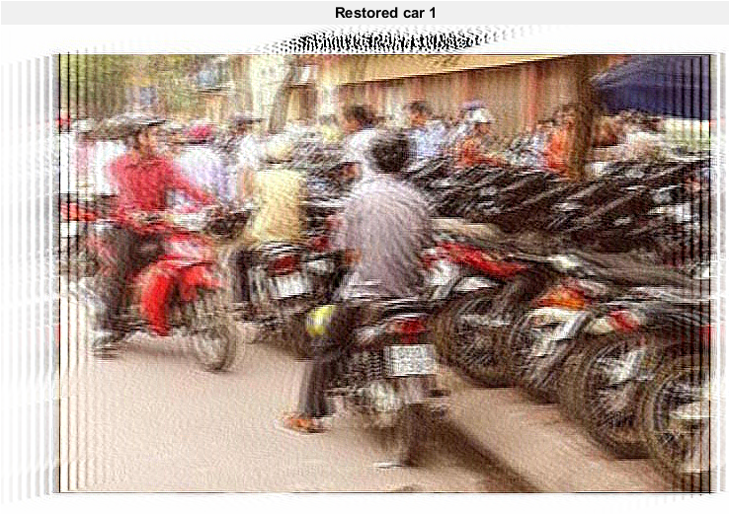

**Image 2**

I=imread('blurredxe2.jpg')

figure;

imshow(I);

title('Original image of picture 1')

Len=11.15;

Theta=11.025;

PSF=fspecial('motion',Len,Theta);

NSR=0.03

restored=deconvwnr(I,PSF,NSR);

figure

imshow(restored);

title('Xe 2 image')

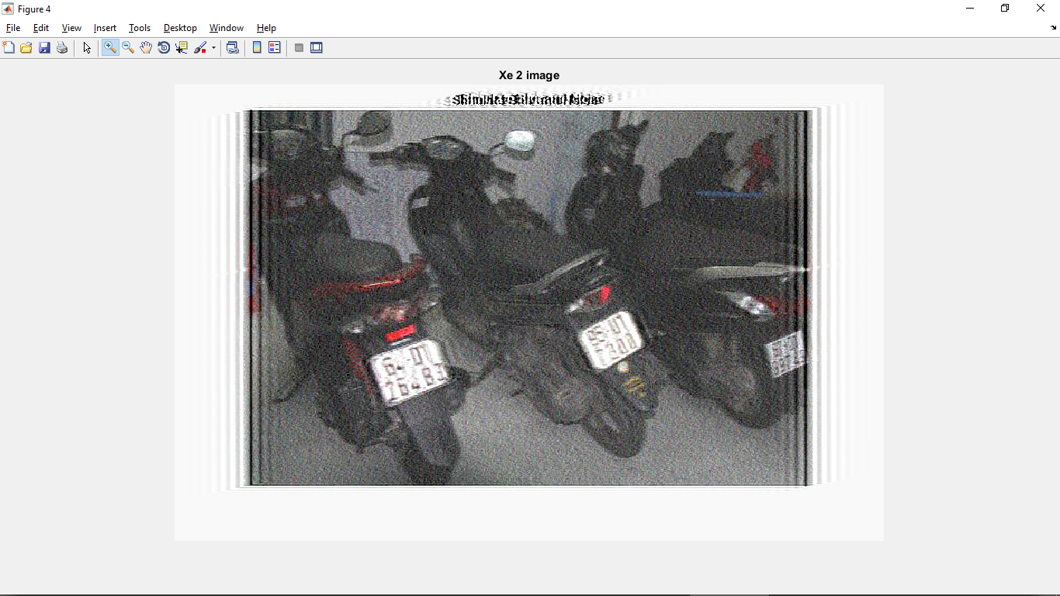

**Image 3**

I=imread('blurredxe3.jpg')

figure;

imshow(I);

title('Original image of picture 1')

Len=25.25;

Theta=12.25;

PSF=fspecial('motion',Len,Theta);

NSR=0.025

restored=deconvwnr(I,PSF,NSR);

figure

imshow(restored);

title('Restored')

